# 4. ReactJS-HOL

Code:

Post.js:

import React, { Component } from 'react';

class Post extends Component {

  render() {

    return (

      <div style={{ marginBottom: '20px' }}>

        <h3>{this.props.title}</h3>

        <p>{this.props.body}</p>

      </div>

    );

  }

}

export default Post;

Posts.js

import React, { Component } from 'react';

import Post from './Post';

class Posts extends Component {

  constructor(props) {

    super(props);

    this.state = {

      posts: [],

      hasError: false,

      error: null

    };

  }

  componentDidMount() {

    this.loadPosts();

  }

  loadPosts() {

    fetch('https://jsonplaceholder.typicode.com/posts')

      .then(response => response.json())

      .then(data => this.setState({ posts: data }))

      .catch(error => {

        this.setState({ hasError: true, error });

        console.error("Error fetching posts:", error);

      });

  }

  componentDidCatch(error, info) {

    alert("An error occurred while rendering Posts component.");

    console.error("Caught error:", error, info);

  }

  render() {

    const { posts, hasError, error } = this.state;

    if (hasError) {

      return <h2>Something went wrong: {error && error.message}</h2>;

    }

    return (

      <div>

        <h2>Blog Posts</h2>

        {posts.map(post => (

          <Post key={post.id} title={post.title} body={post.body} />

        ))}

      </div>

    );

  }

}

export default Posts;

App.js

import React from 'react';

import Posts from './Posts';

function App() {

  return (

    <div className="App">

      <Posts />

    </div>

  );

}

export default App;

File Structure:

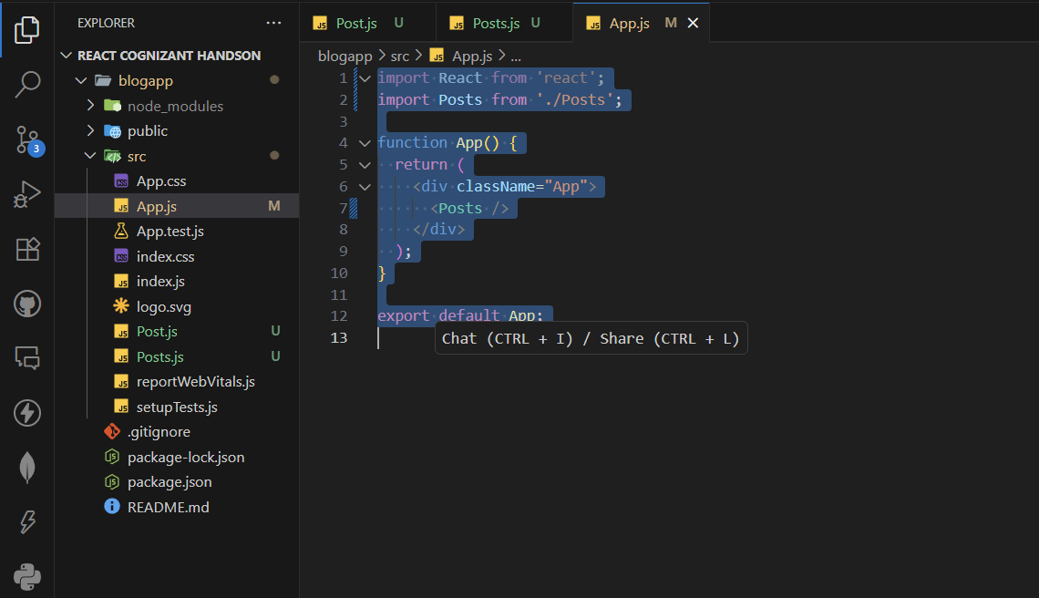

Output:

